Weather API - Technical Specification (version 1.0.0)

Table of Contents

Version history 3

Background 4

Assumptions 5

Architecture 6

Flow diagram 6

Get a list of cities based on country 6

Get the weather information based on country and city 7

Application Layers 8

API specification 9

Get a list of cities based on country 10

Get the weather information based on country and city 12

DataTypes 14

Cities (the normal response to GET /cities) 14

Weather (the normal response to GET /weather) 14

ErrorMessage (error response) 14

Project file structure 15

Mule configuration files 16

Munit test cases 20

Error handling 21

Logging 29

Building and deployment 32

# Version history

|  |  |  |  |
| --- | --- | --- | --- |
| Version | Editor | Description | Date |
| 1.0.0 | Patrick Cheung | Initial release | 1 Feb 2021 |

# Background

The Weather application is a RESTful API implementation which retrieves weather information of a city. It also retrieves the list of cities of a country.

This document provides an explanation of the components within the Weather API application.

# Assumptions

* The node.js application provided is used as a substitution of the GlobalWeather web service. It is assumed that this application is started locally under the same host as our Weather API.

GlobalWeather web service (the node.js application) port: 8080

Weather API port: 8081

* The GlobalWeather web service (the node.js application) is ready before the Weather API application starts up
* Since we cannot access and test the behavior of actual GlobalWeather web service, we deduce the behavior from the mock response provided
  + GetCitiesByCountry
    - The service returns a list of cities based on the country input
    - At least one and only one CountryName has to be specified for each request
    - CountryName requires 1 to 100 characters, accepts alphabetical letters only
  + GetWeather
    - The service returns the weather information of the designated country and city, based on the country and city input
    - At least one and only one country has to be specified for each request
    - At least one and only one country has to be specified for each request
    - CountryName requires 1 to 100 characters, accepts alphabetical letters only
    - CityName requires 1 to 100 characters, accepts alphabetical letters only

# Architecture

## Flow diagram

### Get a list of cities based on country

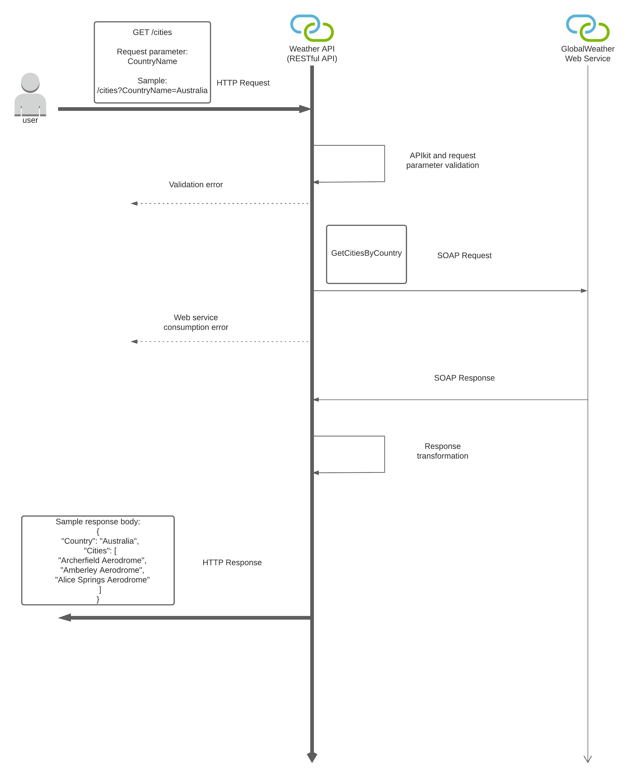

### Get the weather information based on country and city

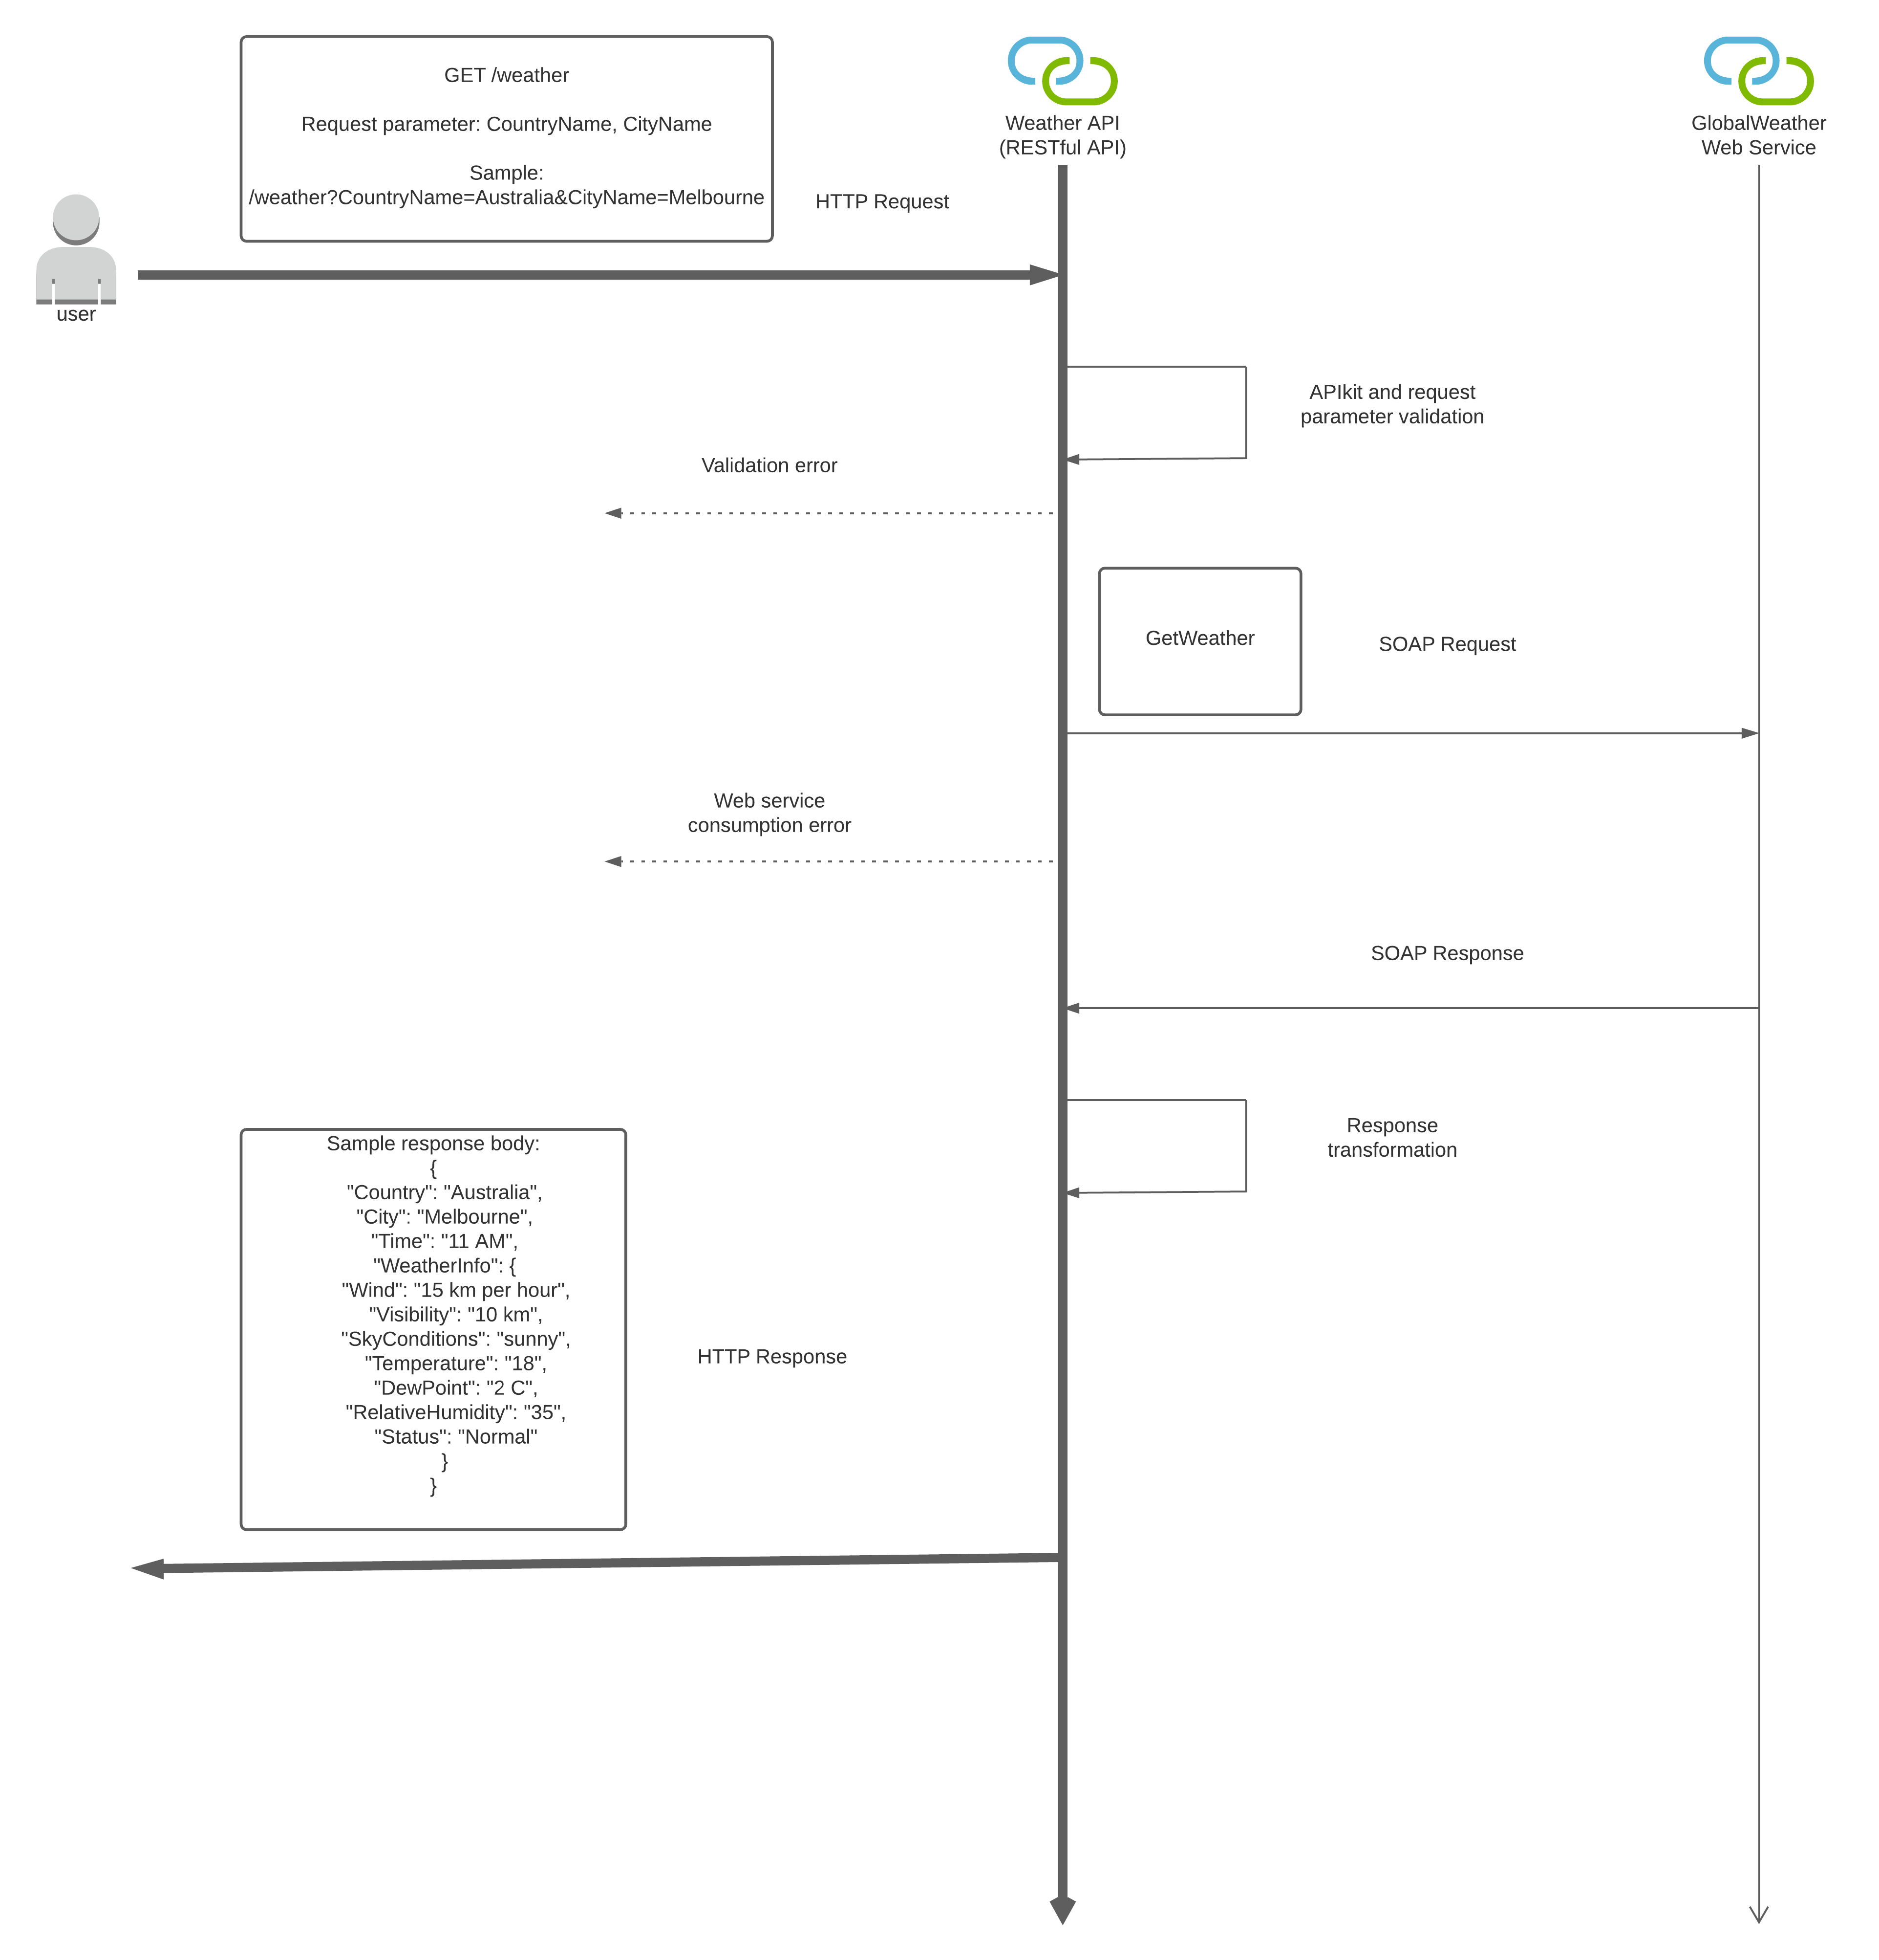

## Application Layers

* GlobalWeather web service
  + The backend web service which provides the cities and weather information.  
    At the time of development, the GlobalWeather web service (WSDL at <http://www.webservicex.com/globalweather.asmx?WSDL>) is not available. A node.js application is started locally to represent the actual GlobalWeather web service backend.
* Weather API
  + Our RESTful API implementation which exposes the functions of the GlobalWeather web service.  
    The API gets the request parameters from caller and calls the GlobalWeather web service for the query. It organizes the returned raw data, then gives the organized response to the caller.

# API specification

The API design can be viewed at Exchange at Anypoint platform at the following link

(Note: link should be available thru 28 Feb 2021 as per Anypoint Platform trial account available period)

<https://anypoint.mulesoft.com/exchange/portals/test-5767/0eabc549-3c9c-45f9-994f-befe322a8c34/weather-api/>

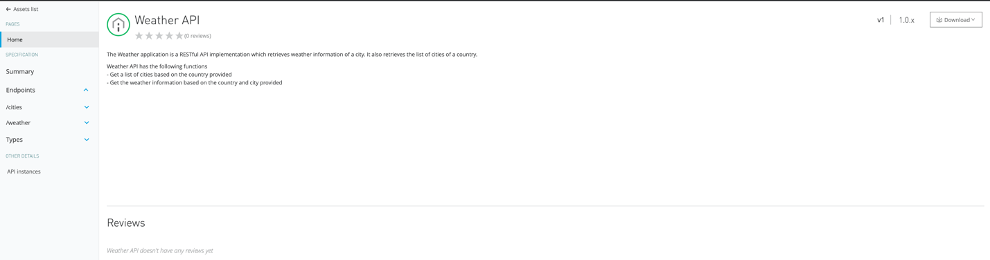

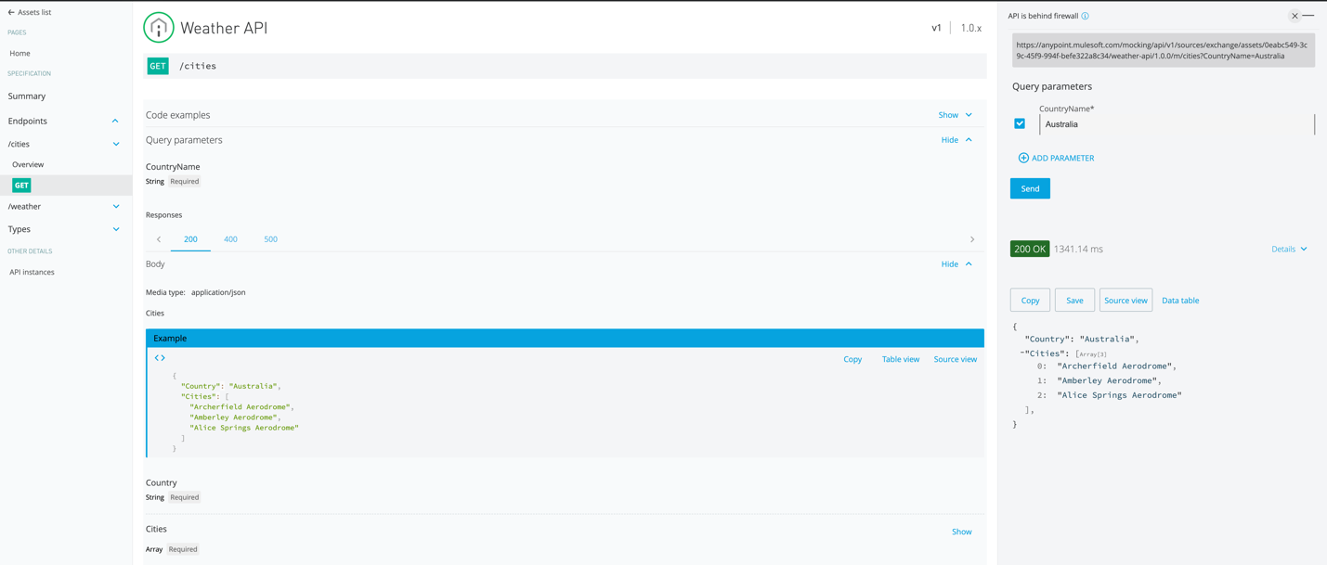

## Get a list of cities based on country

* RAML

Refer to source folder (src/main/resources/api/weather-api.raml)

|  |  |  |  |  |  |  |  |  |
| --- | --- | --- | --- | --- | --- | --- | --- | --- |
| Description | Get a list of cities of the specified country | | | | | | | |
| Verb | GET | | | | | | | |
| Path | /cities | | | | | | | |
| Request | | | | | | | | |
| Query parameters | | | | | | | | |
| Name | Description | Required | Type | Min size | Max size | Regex | Example | Remarks |
| CountryName | Country name | True | string | 1 | 100 | ^[a-zA-Z $]{1,100} | "Australia" | Alphabetical letters only |
| URI parameters | | | | | | | | |
| N/A | | | | | | | | |
| Body | | | | | | | | |
| N/A | | | | | | | | |
| Response | | | | | | | | |
| Body | | | | | | | | |
| Name | Description | Required | Type | Min size | Max size | Regex | Example | Remarks |
| Country | Country name | N/A | string | N/A | N/A | N/A | "Australia" |  |
| Cities | List of cities of the country | N/A | array | N/A | N/A | N/A | [  "Archerfield Aerodrome",  "Amberley Aerodrome",  ] |  |

Sample request:

<http://localhost:8081/api/cities?CountryName=Australia>

Sample response:

{

"Country": "Australia",

"Cities": [

"Archerfield Aerodrome",

"Amberley Aerodrome",

"Alice Springs Aerodrome",

"Brisbane Airport M. O",

"Coolangatta Airport Aws",

"Cairns Airport",

"Charleville Airport",

"Gladstone",

"Longreach Airport",

"Mount Isa Amo",

"Mackay Mo",

"Oakey Aerodrome",

"Proserpine Airport",

"Rockhampton Airport",

"Broome Airport",

"Townsville Amo",

"Weipa City",

"Gove Airport",

"Tennant Creek Airport",

"Yulara Aws",

"Albury Airport",

"Devonport East",

"Goldstream Aws",

"East Sale Aerodrome",

"Hobart Airport",

"Launceston Airport",

"Laverton Aerodrome",

"Moorabbin Airport Aws",

"Mount Gambier Aerodrome",

"Mildura Airport",

"Melbourne Airport",

"Macquarie Island",

"Wynyard West",

"Adelaide Airport",

"Albany Airport",

"Broken Hill Patton Street",

"Ceduna Airport",

"Derby",

"Darwin Airport",

"Bullsbrook Pearce Amo",

"Edinburgh M. O.",

"Forrest Airport",

"Geraldton Airport",

"Kalgoorlie Boulder Amo",

"Kununurra Kununurra Aws",

"Leigh Creek Airport",

"Learmonth Airport",

"Meekatharra Airport",

"Port Hedland Pardoo",

"Parafield Airport",

"Belmont Perth Airport",

"Katherine Aerodrome",

"Woomera Aerodrome",

"Bankstown Airport Aws",

"Canberra",

"Coffs Harbour Mo",

"Cooma",

"Camden Airport",

"Dubbo",

"Norfolk Island Airport",

"Nowra Ran Air Station",

"Richmond Aus-Afb",

"Sydney Airport",

"Tamworth Airport",

"Wagga Airport",

"Williamtown Aerodrome"

]

}

## Get the weather information based on country and city

* RAML

Refer to source folder (src/main/resources/api/weather-api.raml)

|  |  |  |  |  |  |  |  |  |
| --- | --- | --- | --- | --- | --- | --- | --- | --- |
| Description | Get the weather information of the specified country and city | | | | | | | |
| Verb | GET | | | | | | | |
| Path | /weather | | | | | | | |
| Request |  |  |  |  |  |  |  |  |
| Query parameters |  |  |  |  |  |  |  |  |
| Name | Description | Required | Type | Min size | Max size | Regex | Example | Remarks |
| CountryName | Country name | True | string | 1 | 100 | ^[a-zA-Z $]{1,100} | "Australia" | Alphabetical letters only |
| CityName | City name | True | string | 1 | 100 | ^[a-zA-Z $]{1,100} | "Melbourne" | Alphabetical letters only |
| URI parameters | | | | | | | | |
| N/A | | | | | | | | |
| Body | | | | | | | | |
| N/A | | | | | | | | |
| Response | | | | | | | | |
| Body | | | | | | | | |
| Name | Description | Required | Type | Min size | Max size | Regex | Example | Remarks |
| Country | Country name | True | string | N/A | N/A | N/A | "Australia" |  |
| City | City name | True | string | N/A | N/A | N/A | "Melbourne" |  |
| Time | Time | True | string | N/A | N/A | N/A | "11 AM" |  |
| WeatherInfo | Set of weather information of the cit | True | object | N/A | N/A | N/A | {  "Wind": "15 km per hour",  "Visibility": "10 km",  "SkyConditions": "sunny",  "Temperature": "18",  "DewPoint": "2 C",  "RelativeHumidity": "35",  "Status": "Normal"  } |  |
| Wind | Wind speed (km per hour) | True | string | N/A | N/A | N/A | "15 km per hour" |  |
| Visibility | Visibility distance (km) | True | string | N/A | N/A | N/A | "10 km" |  |
| SkyConditions | Sky condition | True | string | N/A | N/A | N/A | "sunny" |  |
| Temperature | Temperature (degree celcius) | True | string | N/A | N/A | N/A | "18" |  |
| DewPoint | Dew point (degree celcius) | True | string | N/A | N/A | N/A | "2 C" |  |
| RelativeHumidity | Relative humidity (percent) | True | string | N/A | N/A | N/A | "35 |  |
| Status | Status | True | string | N/A | N/A | N/A | "Normal" |  |

Sample request:

<http://localhost:8081/api/weather?CountryName=Australia&CityName=Melbourne>

Sample response:

{

"Country": "Australia",

"City": "Melbourne",

"Time": "11 AM",

"WeatherInfo": {

"Wind": "15 km per hour",

"Visibility": "10 km",

"SkyConditions": "sunny",

"Temperature": "18",

"DewPoint": "2 C",

"RelativeHumidity": "35",

"Status": "Normal"

}

}

## DataTypes

### Cities (the normal response to GET /cities)

* RAML

Refer to source folder (src/main/resources/api/types/CitiesDataType.raml)

### Weather (the normal response to GET /weather)

* RAML

Refer to source folder (src/main/resources/api/types/WeatherDataType.raml)

### ErrorMessage (error response)

* RAML

Refer to the source folder (src/main/resources/api/types/ErrorMessageDataType.raml)

|  |  |  |  |  |  |  |  |  |
| --- | --- | --- | --- | --- | --- | --- | --- | --- |
| Body |  |  |  |  |  |  |  |  |
| Name | Description | Required | Type | Min size | Max size | Regex | Example | Remarks |
| message | Error message | True | String | N/A | N/A | N/A | "Invalid CountryName 1" |  |

# Project file structure

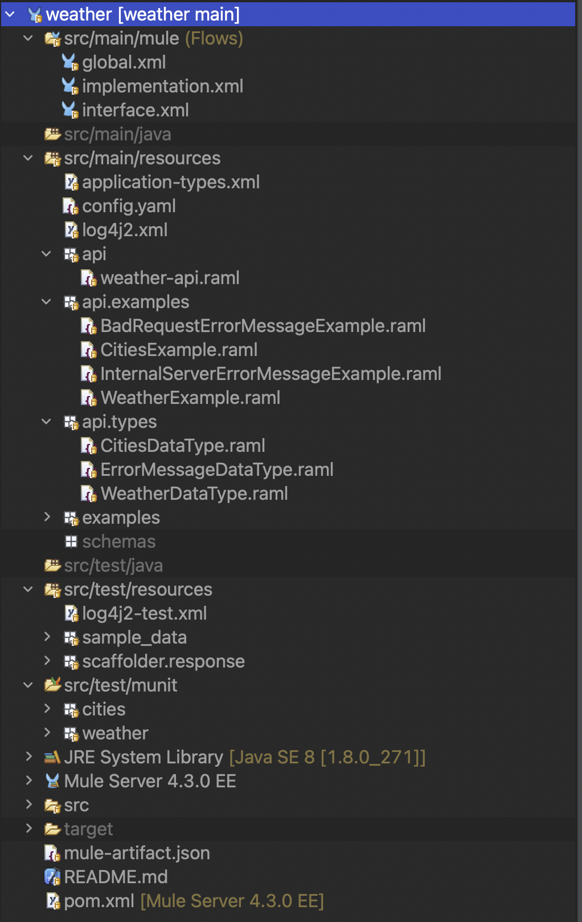

## Mule configuration files

* global.xml

This file serves as the configuration file for all the configurations used by the mule flow components (e.g. HTTP listener, HTTP request, Web service consume, etc.)

Also, the global error handler is implemented here.

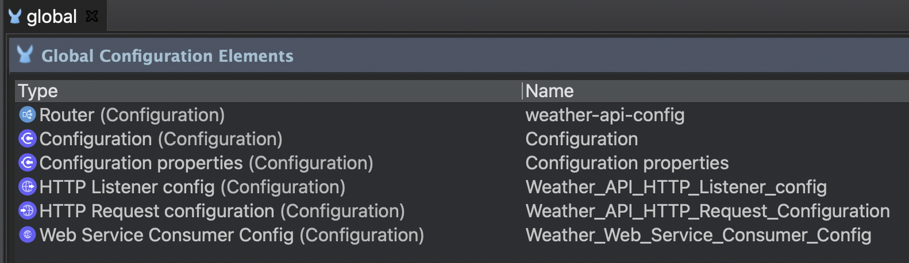

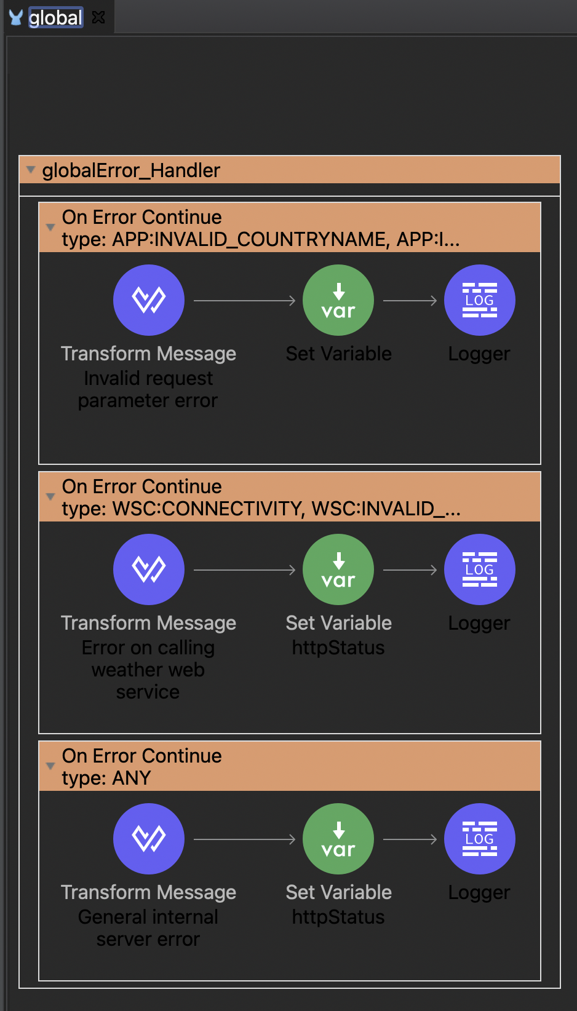

* interface.xml

This file serves as the starting point of the API flow. When the request is first received, the APIkit will check if the request is valid.

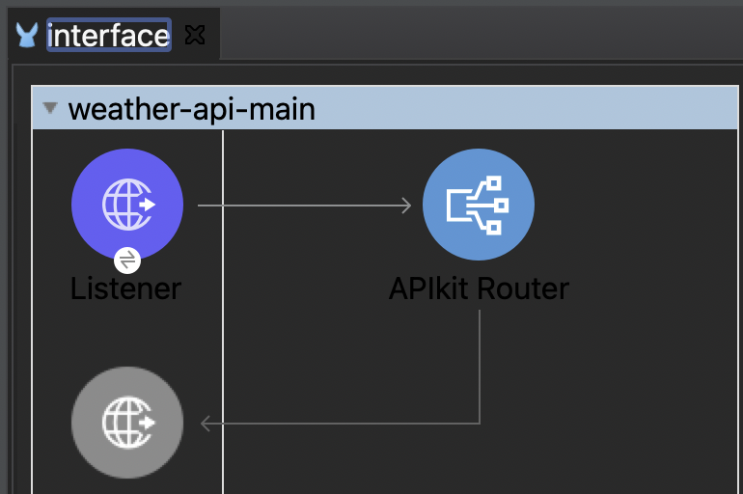

If it is valid it will pass on to the target endpoint flow.

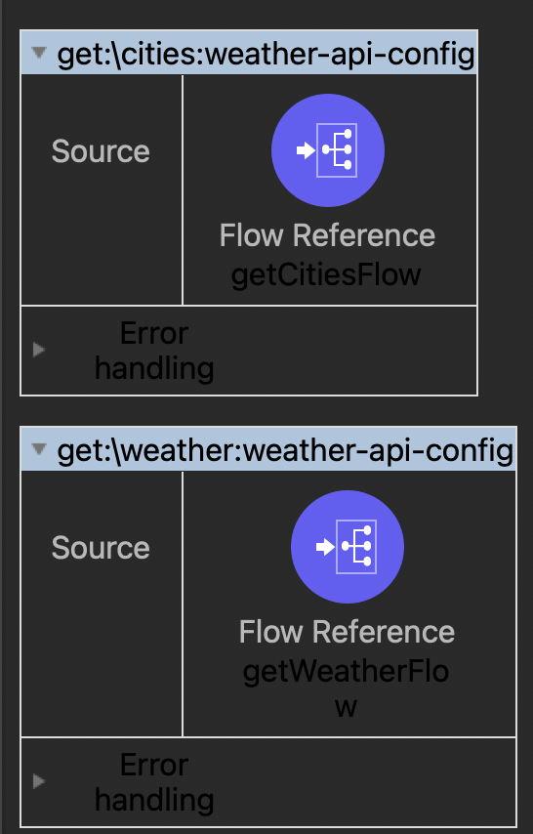

If the request is not valid, it will delegate to the APIkit error flow for handling.

Refer to APIkit error handler description in later sections.

* implementation.xml

This file serves as the actual implementation of the API operations.

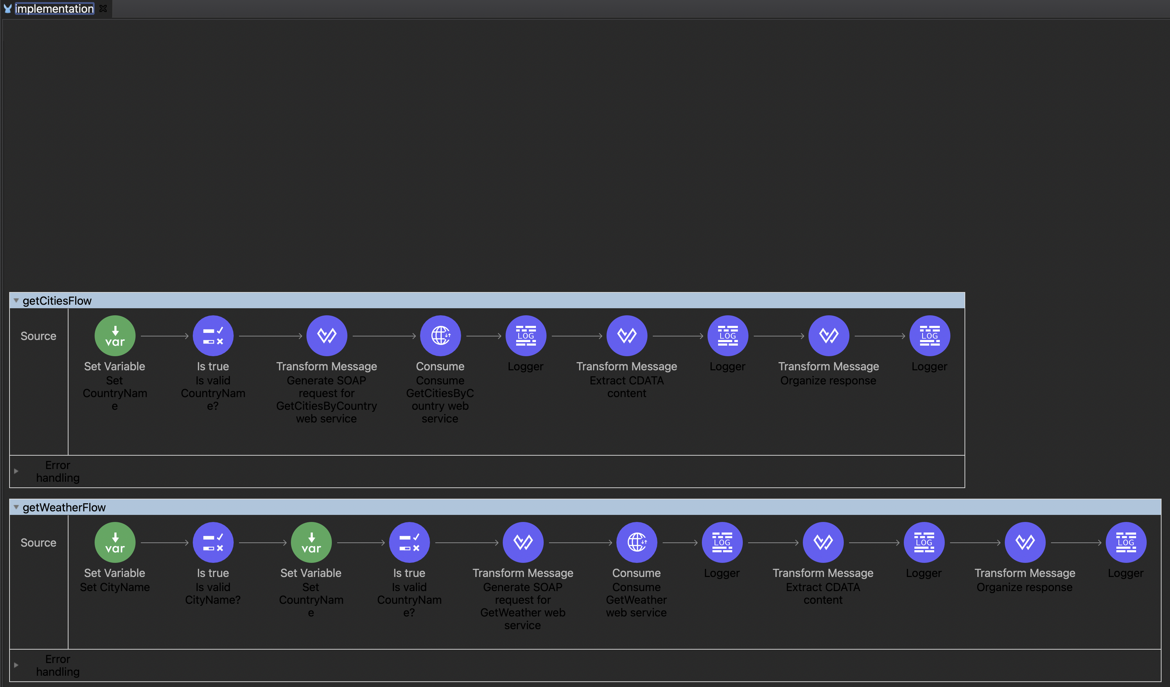

## Munit test cases

* Munit test cases has been grouped by each of the endpoints.

Each of the endpoints has tests on the following categories

* + Normal cases
    - These cases are executed end-to-end by calling the actual Weather API endpoints
  + Error cases in the APIkit level
    - These cases are executed end-to-end by calling the actual Weather API endpoints
      * Some unreproducible scenarios are performed with a mock error in the flow components
  + Error cases in the endpoint execution flow (i.e. passed the APIkit level checking, but encountered error in the endpoint)
    - These cases are executed by calling the endpoint flows

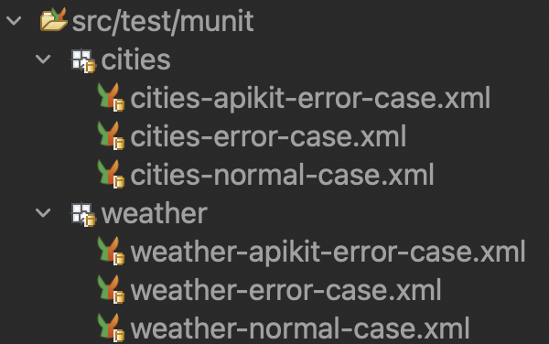

## Error handling

* Global error handler
  + Errors raised from within the execution flow will be handled by the global error handler

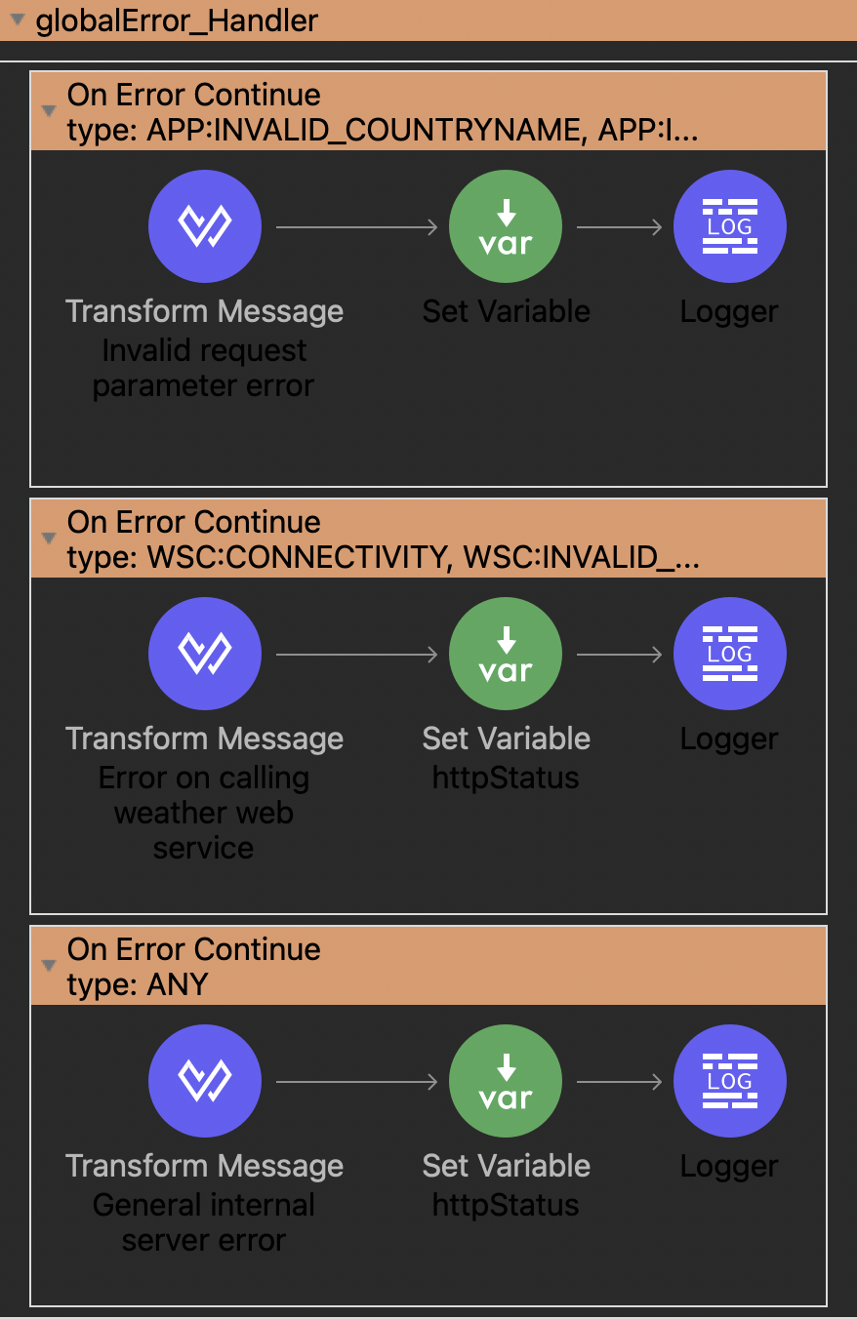

* + Parameter validation error
    - Occurs when request parameters fail validation at the validation component

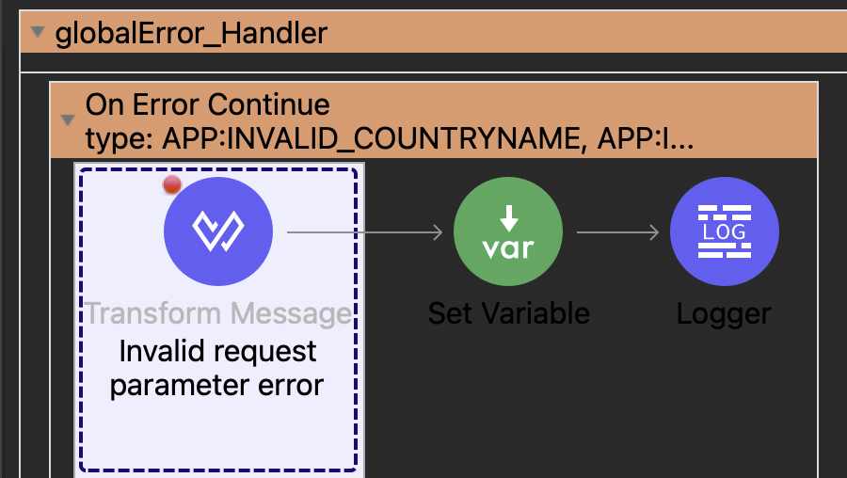

Sample:

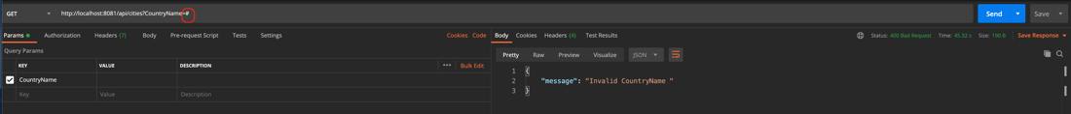

* + Web service error
    - Occurs when the GlobalWeather backend is unavailable, or there is problem with the WSDL file

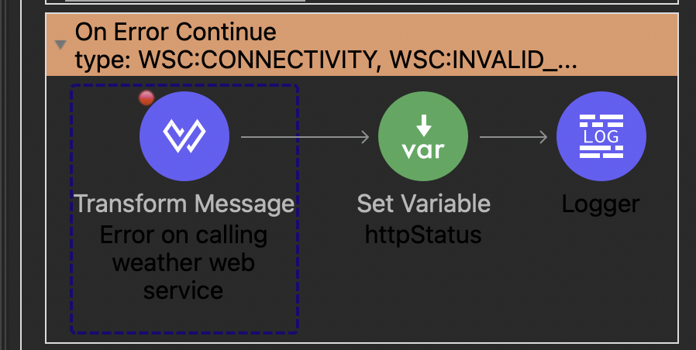

Sample:

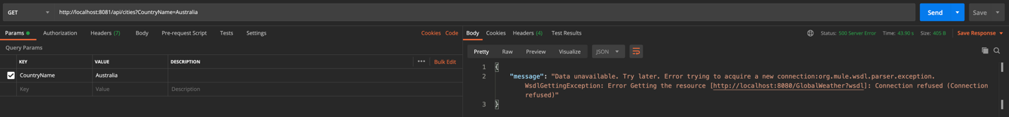

* + General internal server error
    - Occurs when some issues occur with our server which makes our execution flow to fail to complete

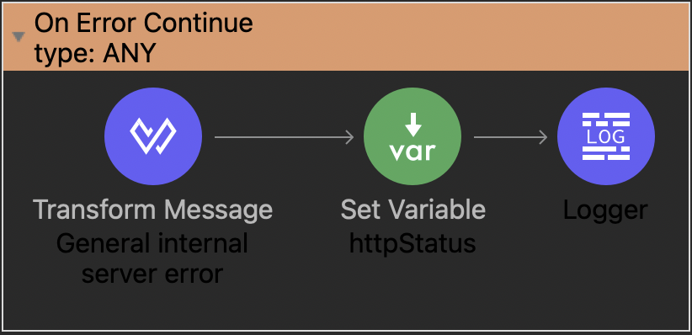

* APIkit error handler
  + Handles errors when there are issues with the request which makes it unable to trigger any target flow

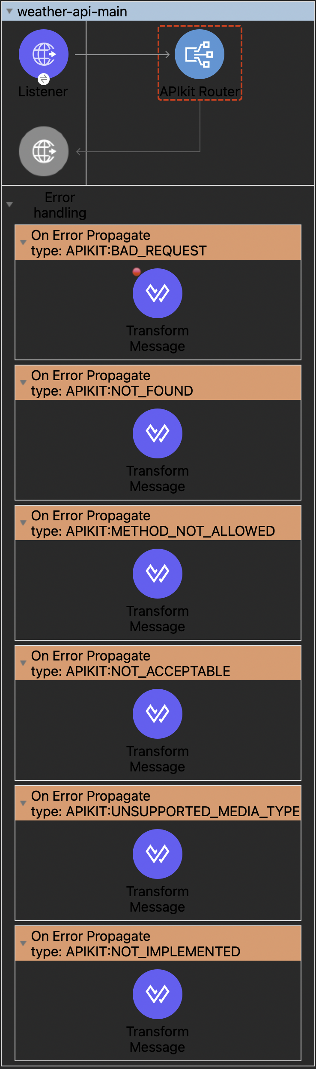

* BAD request (HTTP 400)

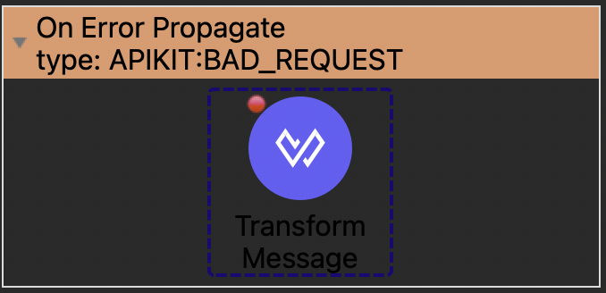

Sample:

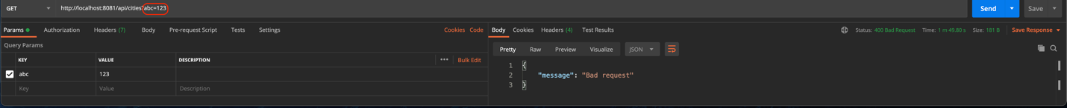

* RESOURCE NOT FOUND (HTTP 404)

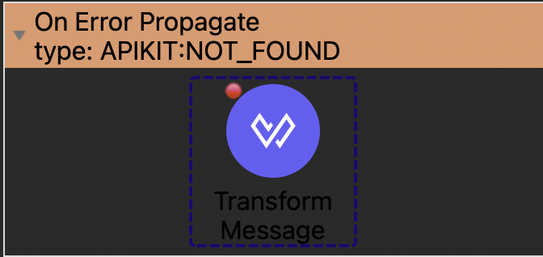

Sample:



* METHOD NOT ALLOWED (HTTP405)

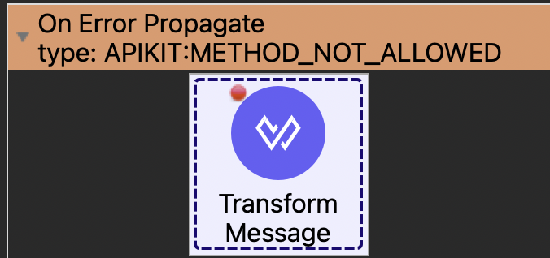

Sample:



* NOT ACCEPTABLE (HTTP406)

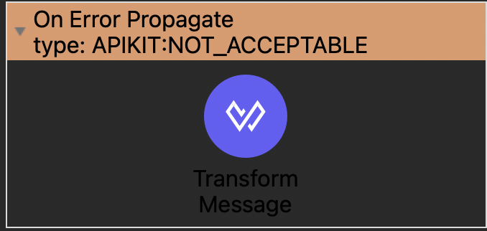

* UNSUPPORTED MEDIA TYPE (HTTP415)

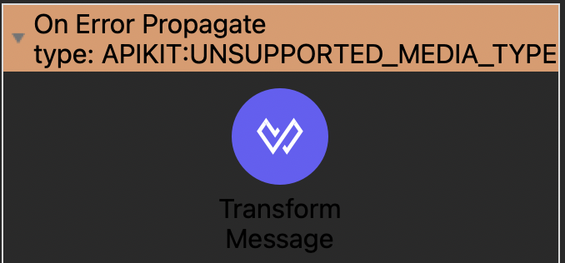

* NOT IMPLEMENTED (HTTP501)

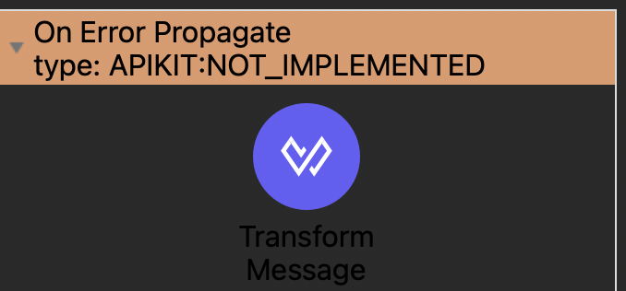

## Logging

* Log components in the API flow

General logger components in the flow are set with DEBUG level, which means the Mule logger will not log them if log setting is configured to log at INFO level only.

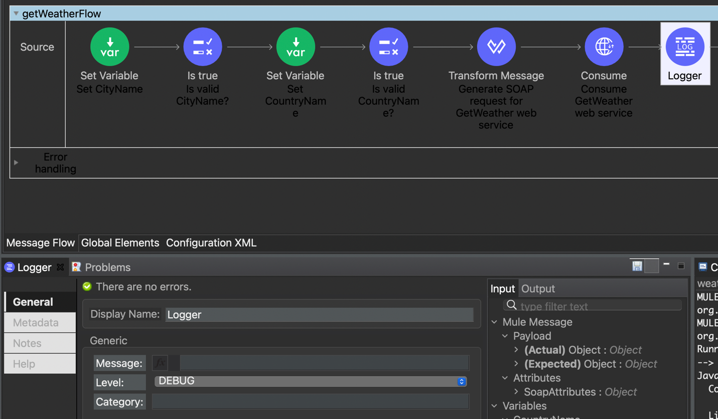

Error logger components are set with ERROR level, which means they are expected to be logged at all times.

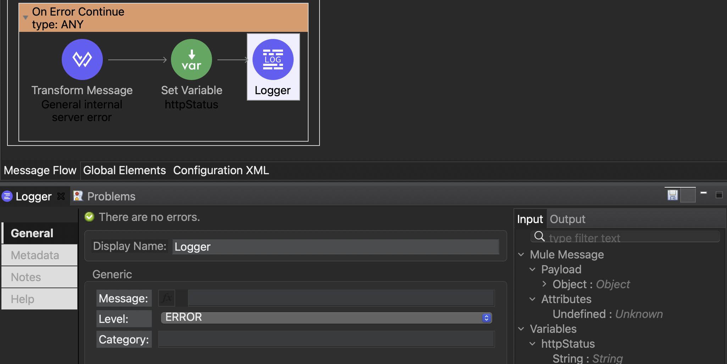

* Log file

As per current setting log file is configured to write application logs at the following location

${sys:mule.home}/logs/weather.log

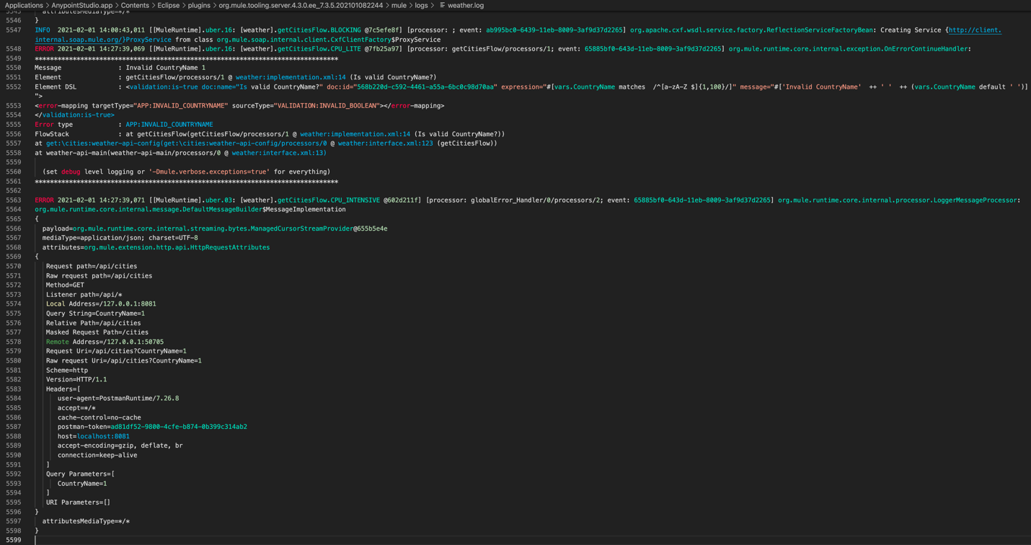

MULE_HOME is where the Mule runtime is located. If you are running the application from within Anypoint Studio, you can see the value of MULE_HOME when you start up the mule runtime.

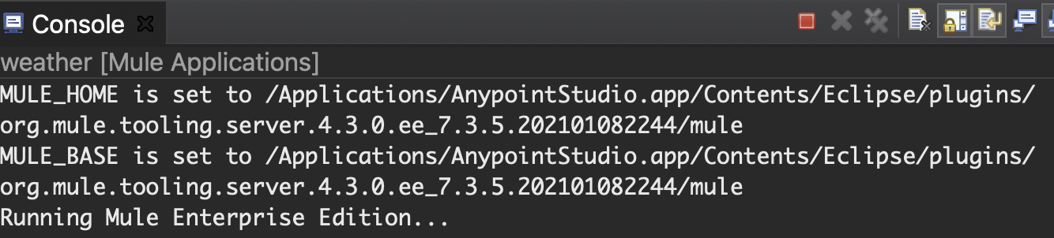

Logs will be renamed and backed-up when it reaches 10MB, and no more than 10 backups will be kept.

* Log level

The log level for the Mule logger (i.e. what level of flow component logs that he mule logger will log) and also the root log level (i.e. what level of logs will be written to log file, this is independent from the logger log level) is designed to be dynamically specified in runtime.

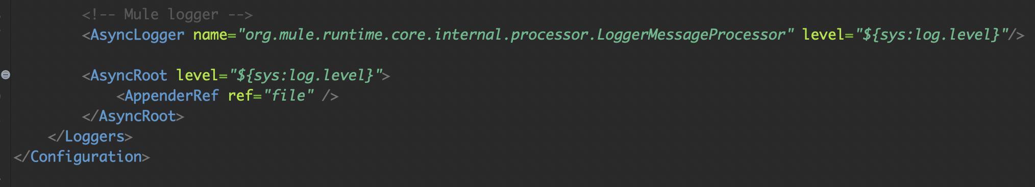

You should specify the log level when you start up the application.

e.g. if you running the application using Anypoint Studio

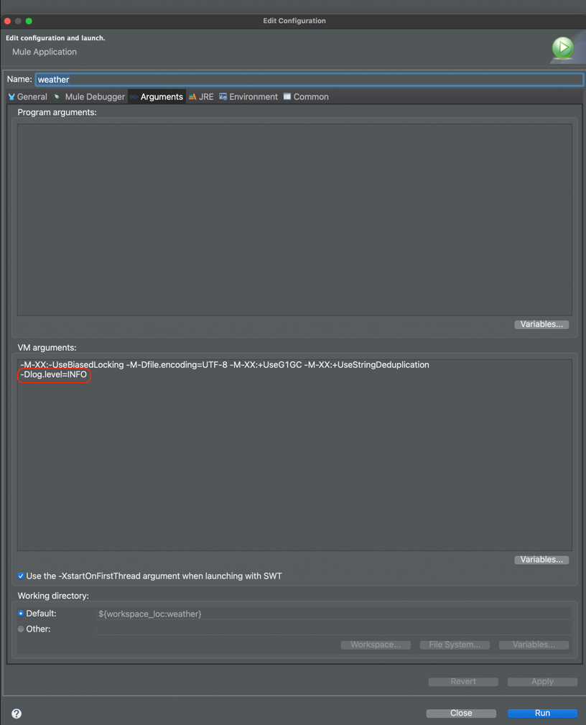

The log settings can be changed by updating src/main/resources/log4j2.xml.

# Building and deployment

Refer to instructions in the Git repository

<https://github.com/patrickpycheung/weather>